Consolidation & Preparation Time
Term 2 Weeks 3 and 4

Are you serious about improving your learning? Do you take ownership of that process, or do you just hope it happens?

If you do want to genuinely develop as a learner you must work at becoming metacognitive. CP time provides the perfect opportunity to understand what this is and to work at building your skills.

What is metacognition? Why does it matter?

Metacognition is the ability to THINK ABOUT YOUR THINKING. It is being aware of your own learning.

In academic terms it’s not WHAT do I need to learn, but HOW can I learn it best.

Metacognition entails understanding the goals of the learning process, figuring out the best strategies for learning, and assessing whether your learning goals are being met.

If you are metacognitive you see yourself as an agent in the learning process and realise that learning is an active, strategic activity.

As you progress further into Term 2 with your units of study it is the perfect time to invest in building your metacognitive skills (well in advance of the assessment period).

Here are some basic metacognitive skills to focus on:

- Being able to talk about what you understand about a topic;
- Figuring out what you are yet to understand;
- Realising the connection between the learning in a lesson and what was learned in previous lessons;
- Monitoring your understanding during an activity and seeking assistance when needed;
- Choosing which strategies to employ in your learning, and when to employ them; and
- Evaluating whether a particular learning strategy was successful in a given circumstance, and if not, changing course if necessary.

Why is metacognition SO important?

Metacognition is linked to improved learning outcomes. Successful students are metacognitive students. It makes sense that individuals who are strategic in their learning are more successful than those who do not reflect on the learning process.

For instance, metacognitive learners are more likely to notice when what they are studying does not make sense. These are the students who try to clarify their understanding rather than passively continuing on with their learning.

Metacognition is something you can learn if you put effort into thinking about the ways you learn successfully.

Here are 7 questions you can ask this term to build your capacity for metacognition. Start today!

- What should I do first?
- Is anything confusing to me?
- Can I explain what I’ve learned?
- Should I ask for extra help?
- Why did I get that answer wrong?
- Can I apply this in different contexts?
- How can I do better next time?

Questions like these help you plan more effectively, understand your strengths and weaknesses, and reflect on and improve your learning.

Source: Mastering Metacognition (activelylearn.com)

What this video on metacognition to consolidate the ideas above.

Metacognition: The Skill that Promotes Advanced Learning

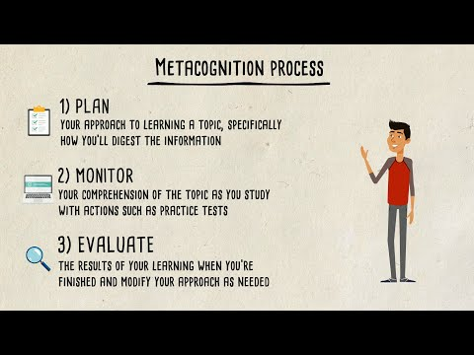

https://www.youtube.com/watch?v=elZFL4FLVLE&t=3s

CP time provides the perfect opportunity for you to develop metacognition. Last week you were encouraged to consider if you are using CP time effectively. Let’s revisit last weeks’ advice.
What can you do if you have been honest and identified you are not using CP time effectively? Take your first metacogntive steps ….
- Go back and read the Senior School Student Handbook issued at the start of the year that outlines the types of activities you should be engaged in during CP time.
- Talk to your Form Tutor or Head of Year to get their advice.
- Talk to peers who you know are using CP time well to get their advice.
- Go back over last term’s CP time resources.
- Take small steps and do something positive today. Right now!

